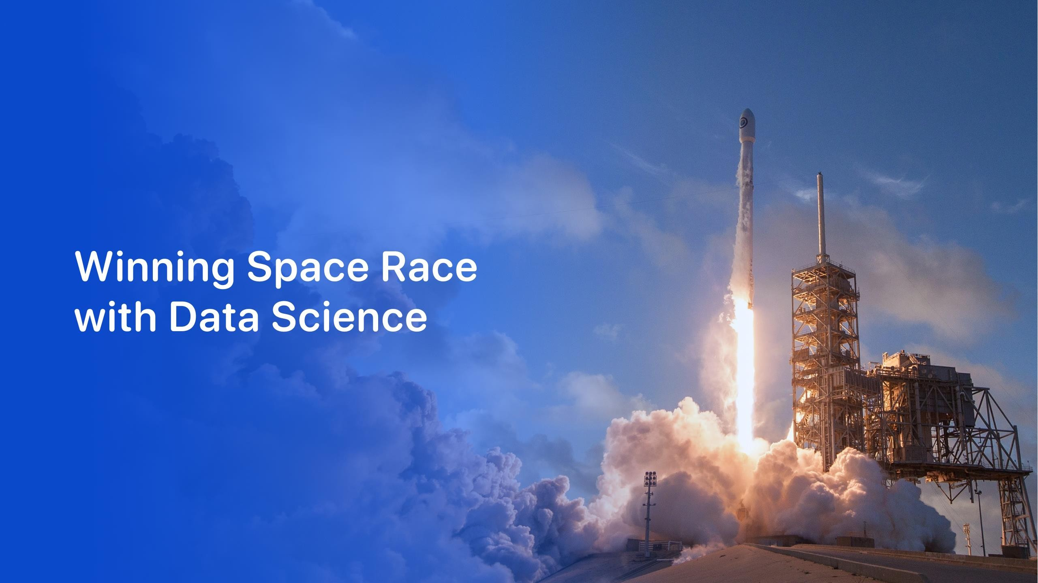



Tejaswi Kumawat

# Outline

* ExecutiveSummary
* Introduction
* Methodology
* Results
* Conclusion
* Appendix

2

# ExecutiveSummary

* Summaryofmethodologies
  + Datacollection
  + Datawrangling
  + EDAwithdatavisualization
  + EDAwithSQL
  + BuildinganinteractivemapwithFolium
  + BuildingaDashboardwithPlotlyDash
  + Predictiveanalysis(Classification)
* Summaryofallresults
  + EDAresults
  + Interactiveanalytics
  + Predictiveanalysis 3

# Introduction

* Projectbackgroundandcontext
  + SpaceXadvertisesFalcon9rocketlaunchesonitswebsite,withacostof62milliondollars;other providers cost upward of 165 million dollars each, much of the savings is becauseSpaceXcanreusethefirststage.
* Problemsyouwanttofindanswers
  + TheprojecttaskistopredictingifthefirststageoftheSpaceXFalcon9rocketwilllandsuccessfully

4



5

# Methodology

ExecutiveSummary

* Datacollectionmethodology:
  + SpaceXRestAPI
  + WebScrappingfromWikipedia
* Performdatawrangling
  + OneHotEncodingdatafieldsforMachineLearninganddatacleaningofnullvaluesandirrelevantcolumns
* Performexploratorydataanalysis(EDA)usingvisualizationandSQL
* PerforminteractivevisualanalyticsusingFoliumandPlotlyDash
* Performpredictiveanalysisusingclassificationmodels
  + LR,KNN,SVM,DTmodelshavebeenbuiltandevaluatedforthebestclassifier

6

# DataCollection

* Thefollowingdatasetswascollected:
  + 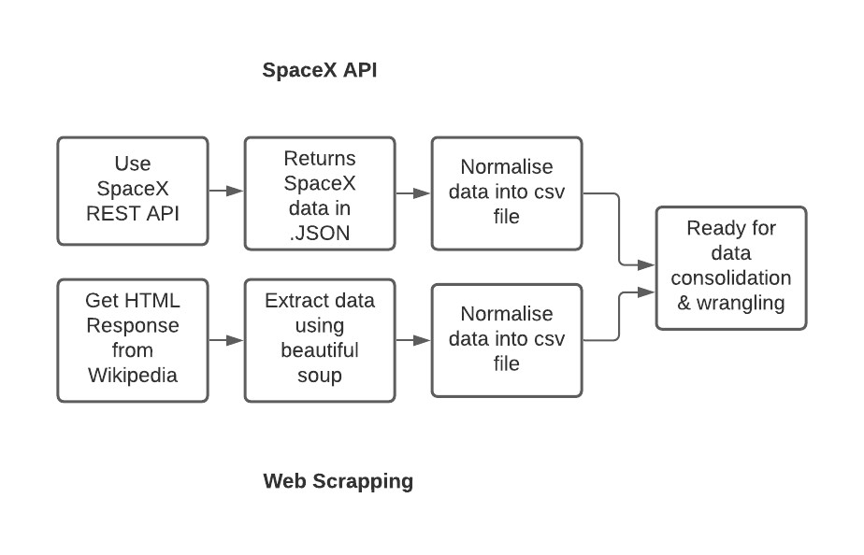SpaceXlaunchdatathatisgatheredfromtheSpaceXRESTAPI.
  + This API will give us data about launches, includinginformationabouttherocketused,payloaddelivered,launchspecifications,landingspecifications, andlandingoutcome.
  + TheSpaceXRESTAPIendpoints,orURL,startswithapi.spacexdata.com/v4/.
  + AnotherpopulardatasourceforobtainingFalcon9Launch data is web scraping Wikipedia usingBeautifulSoup.

7

# DataCollection–SpaceXAPI

* DatacollectionwithSpaceXRESTcalls

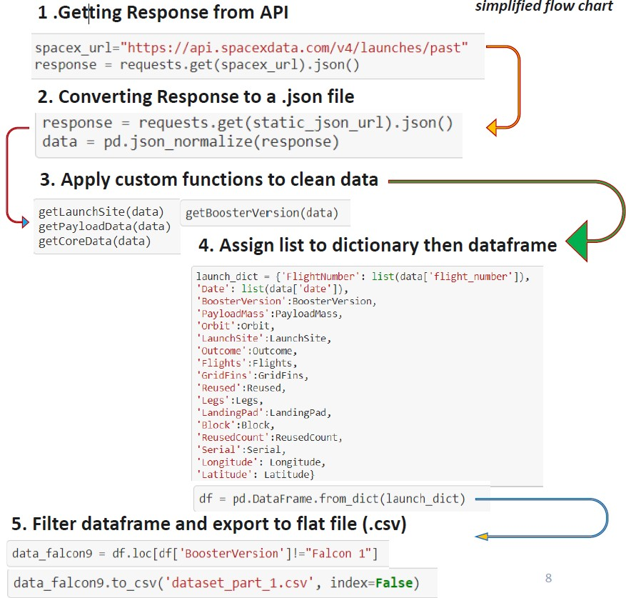

8

# DataCollection-Scraping

* + WebScrappingfromWikipedia

Placeyourflowchartofwebscrapinghere

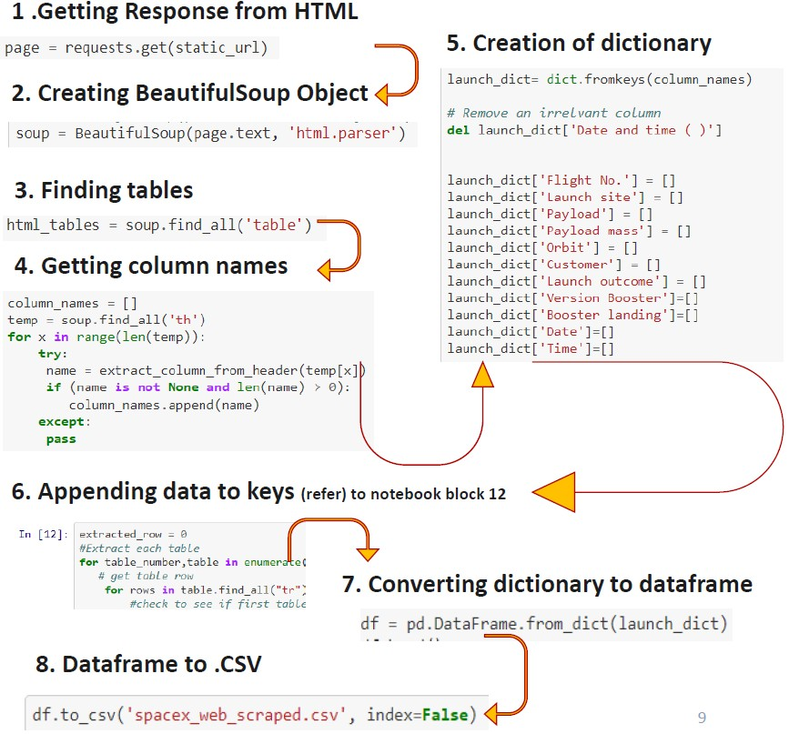

9

# DataWrangling

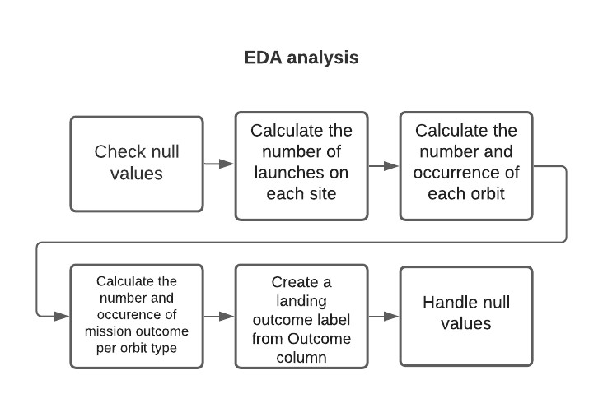

10

# EDAwithDataVisualisation

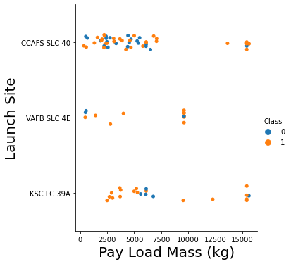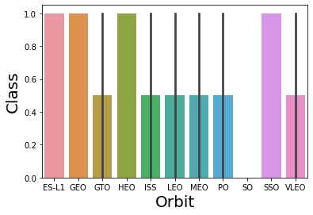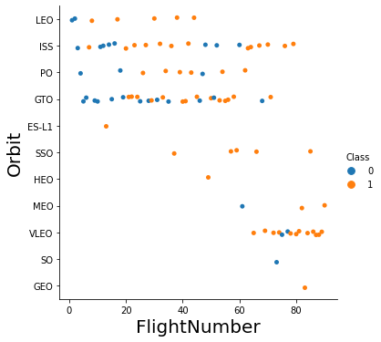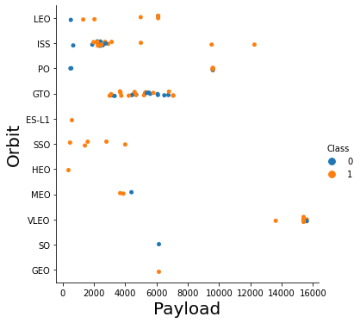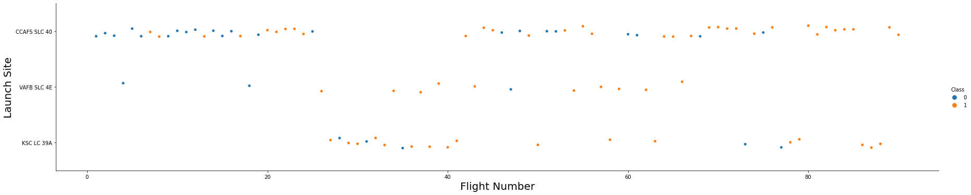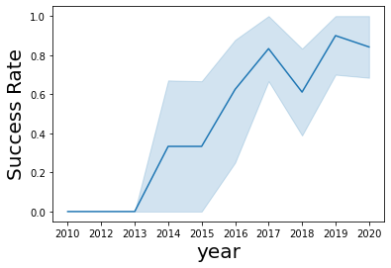

11

# EDAwithSQL

* SQLqueriesperformedinclude:
  + Displayingthenamesoftheuniquelaunchsitesinthespacemission
  + Displaying5recordswherelaunchsitesbeginwiththestring'KSC’
  + Displayingthetotalpayloadmasscarriedbyboosterslaunched byNASA(CRS)
  + DisplayingaveragepayloadmasscarriedbyboosterversionF9v1.1
  + Listingthedatewherethesuccessfullandingoutcomeindroneshipwasachieved.
  + Listingthenamesoftheboosterswhichhavesuccessingroundpadandhavepayloadmassgreaterthan4000butlessthan6000
  + Listingthetotalnumberofsuccessfulandfailuremissionoutcomes
  + Listingthenamesofthebooster_versionswhichhavecarriedthemaximumpayloadmass.
  + Listingtherecordswhichwilldisplaythemonthnames,successfullanding_outcomesingroundpad,booster
  + versions,launch_siteforthemonthsinyear2017
  + Rankingthecountofsuccessfullanding_outcomesbetweenthedate20100604and20170320indescendingorder.

12

# BuildanInteractiveMapwithFolium

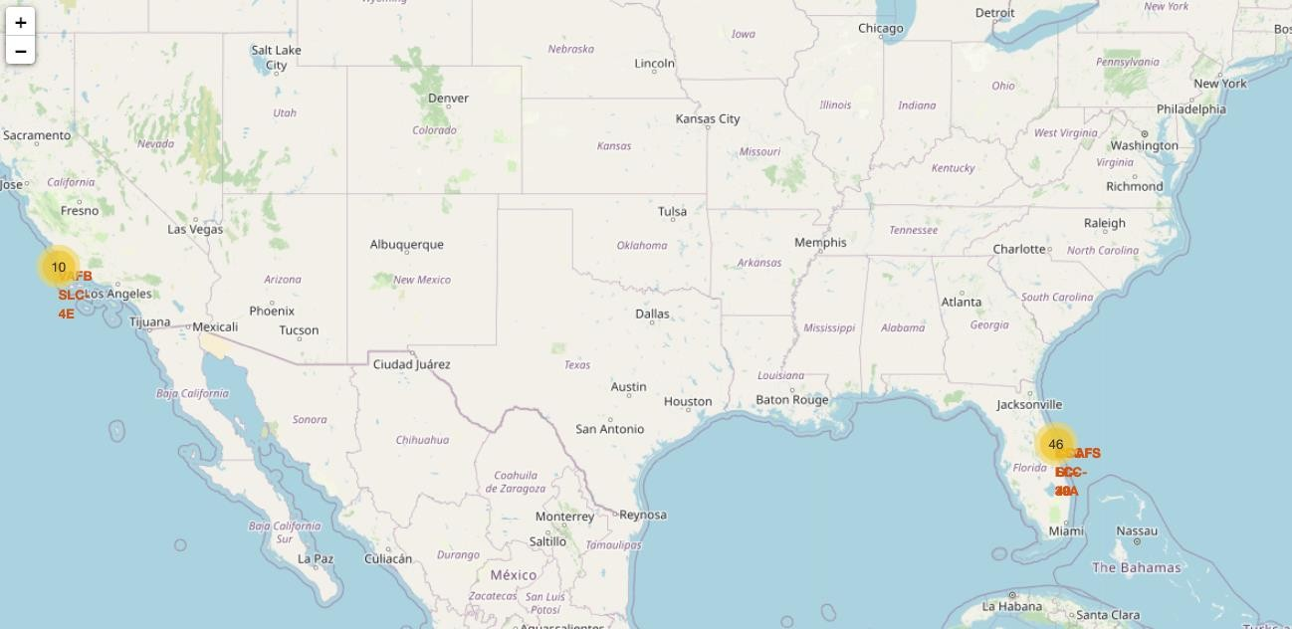

Mapmarkers havebeenaddedtothemapwithaimtofindinganoptimallocationforbuildingalaunchsite 13

# BuildaDashboardwithPlotlyDash

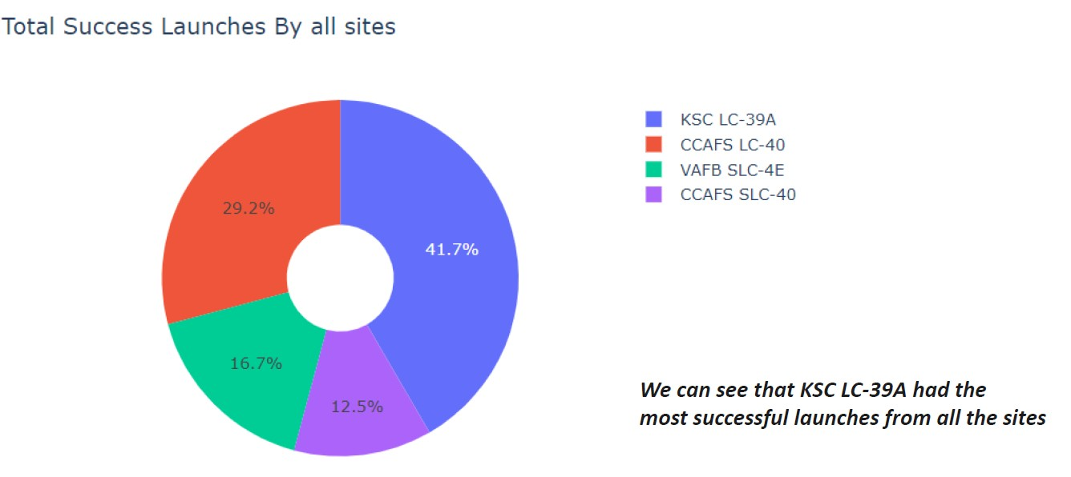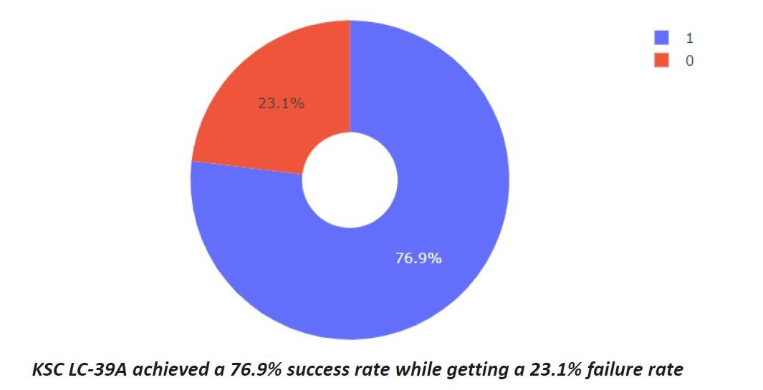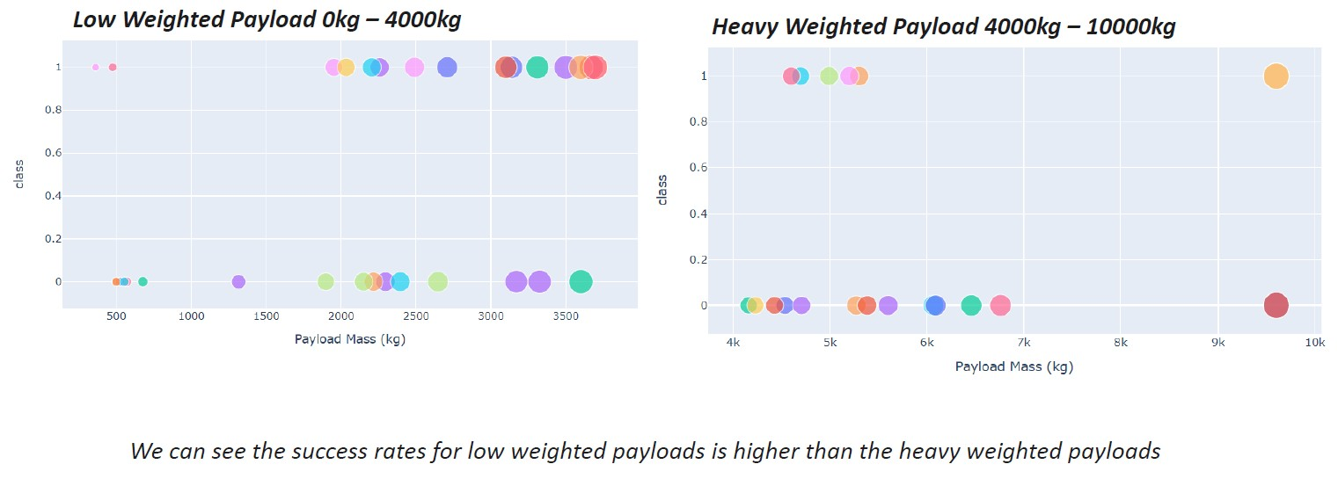

14

# PredictiveAnalysis(Classification)

* 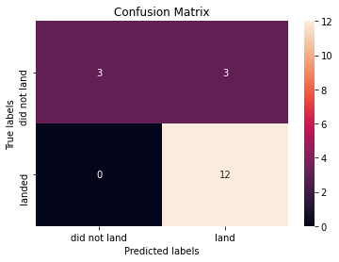The SVM, KNN, and Logistic Regression model achieved the highestaccuracyat83.3%,whiletheSVMperformsthebestintermsofAreaUnderthe Curveat 0.958.



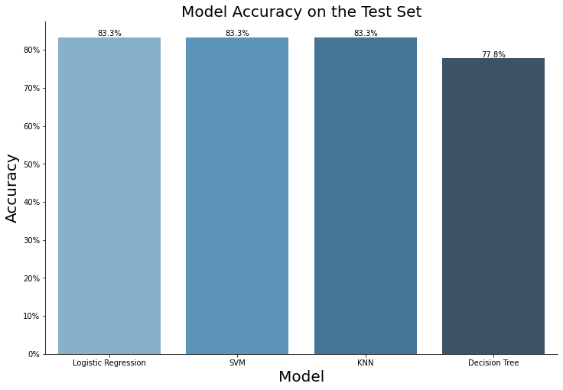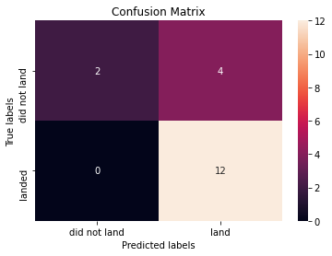

15

# Results

* + TheSVM,KNN,andLogisticRegression modelsarethebestintermsofpredictionaccuracyforthisdataset.
  + Lowweightedpayloadsperformbetterthantheheavierpayloads.
  + ThesuccessratesforSpaceXlaunchesisdirectlyproportionaltimeinyearstheywilleventuallyperfectthelaunches.
  + KSCLC39Ahadthemostsuccessfullaunchesfromallthesites.
  + OrbitGEO,HEO,SSO,ESL1hasthebestSuccessRate.

16



# FlightNumbervs.LaunchSite



* + - LaunchesfromthesiteofCCAFSSLC40aresignificantlyhigherthan

launchesformothersites.

18

# Payloadvs.LaunchSite

* + - * ThemajorityoflPayLoadswithlowerMasshavebeenlaunchedfromCCAFSSLC40.

19

# SuccessRatevs.OrbitType

* TheorbittypesofES-L1,GEO,HEO,SSO are among the highest successrate.

20

# FlightNumbervs.OrbitType

* AtrendcanbeobservedofshiftingtoVLEOlaunchesinrecentyears.

21

# Payloadvs.OrbitType

* TherearestrongcorrelationbetweenISSandPayloadattherangearound2000,aswellasbetweenGTOandtherangeof4000-8000.

22

# LaunchSuccessYearlyTrend

* Launch success rate has increasedsignificantly since 2013 and hasstablisedsince2019,potentiallyduetoadvance in technology and lessonslearned.

23

# AllLaunchSiteNames

* %sqlselectdistinct(LAUNCH_SITE)fromSPACEXTBL

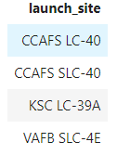

24

# LaunchSiteNamesBeginwith'CCA'

* %sqlselect*fromSPACEXTBLwhereLAUNCH_SITElike'CCA%'limit5

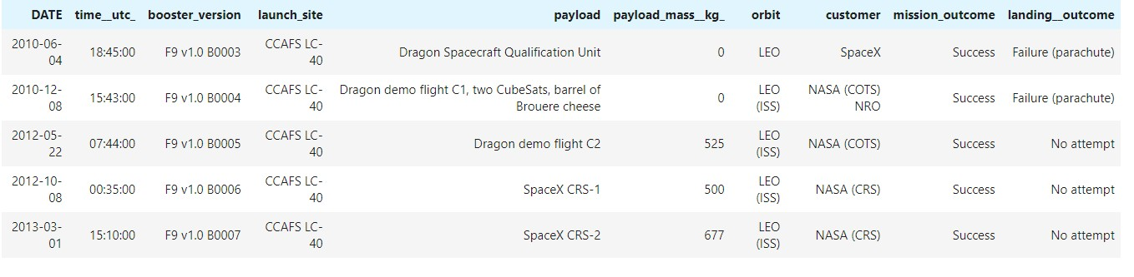

25

# TotalPayloadMass

* %sqlselectsum(PAYLOAD_MASS KG_)fromSPACEXTBLwhereCUSTOMER

='NASA(CRS)'

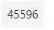

26

# AveragePayloadMassbyF9v1.1

* %sqlselectavg(PAYLOAD_MASS KG_)fromSPACEXTBLwhereBOOSTER_VERSION='F9v1.1'

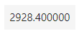

27

# FirstSuccessfulGroundLandingDate

* %sqlselectmin(DATE)fromSPACEXTBLwhereLanding Outcome='Success(groundpad)'

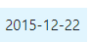

28

SuccessfulDroneShipLandingwithPayloadbetween4000and6000

* %sqlselectBOOSTER_VERSIONfromSPACEXTBLwhereLanding Outcome

='Success(droneship)'andPAYLOAD_MASS KG_>4000and

PAYLOAD_MASS KG_<6000

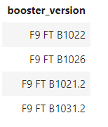

29

TotalNumberofSuccessfulandFailureMissionOutcomes

* %sql select count(MISSION_OUTCOME) from SPACEXTBL whereMISSION_OUTCOME='Success'orMISSION_OUTCOME='Failure(inflight)'

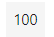

30

# BoostersCarriedMaximumPayload

* 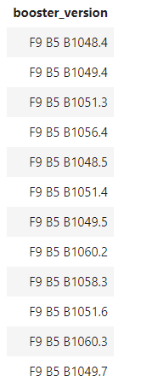%sql select BOOSTER_VERSION from SPACEXTBL wherePAYLOAD_MASS KG_=(selectmax(PAYLOAD_MASS KG_)fromSPACEXTBL)

31

# 2015LaunchRecords

* %sqlselect*fromSPACEXTBLwhereLanding Outcomelike'Success%'and

(DATEbetween‘2015-01-01'and ‘2015-12-31') orderbydatedesc

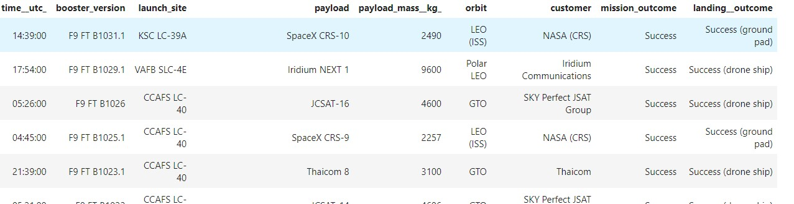

32

Rank LandingOutcomesBetween2010-06-04and2017-03-20

* %sqlselect*fromSPACEXTBLwhereLanding Outcomelike'Success%'and(DATEbetween'2010-06-04'and'2017-03-20')orderbydatedesc

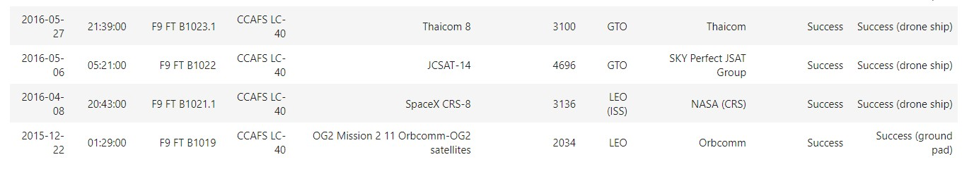

33



# Alllaunchsitesmarkedonamap

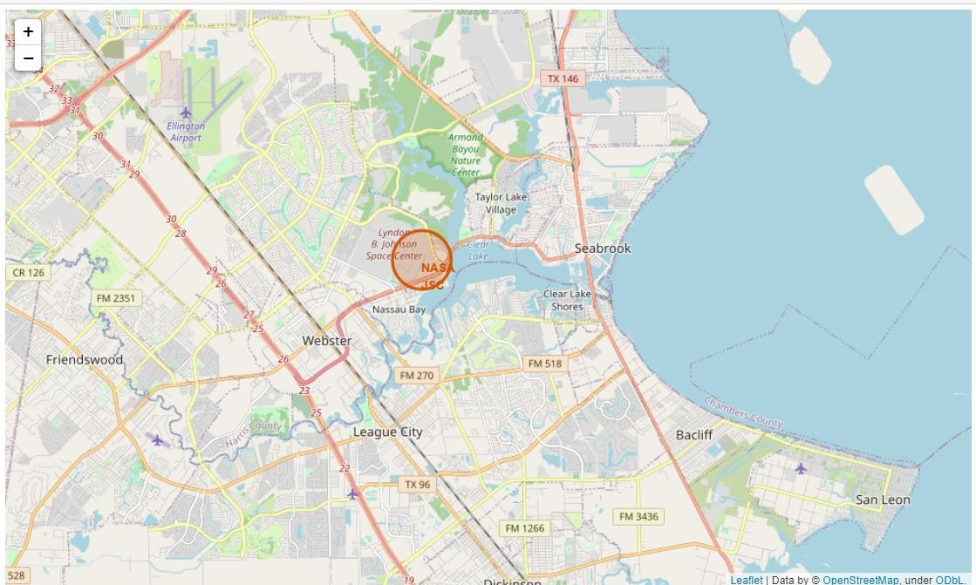35

# Success/failedlaunchesmarkedonthemap

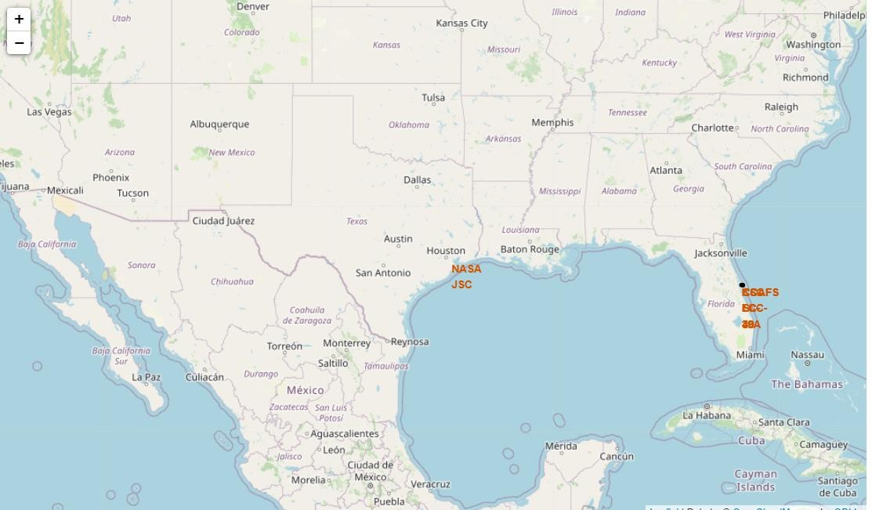36

# Distancesbetweenalaunchsitetoitsproximities

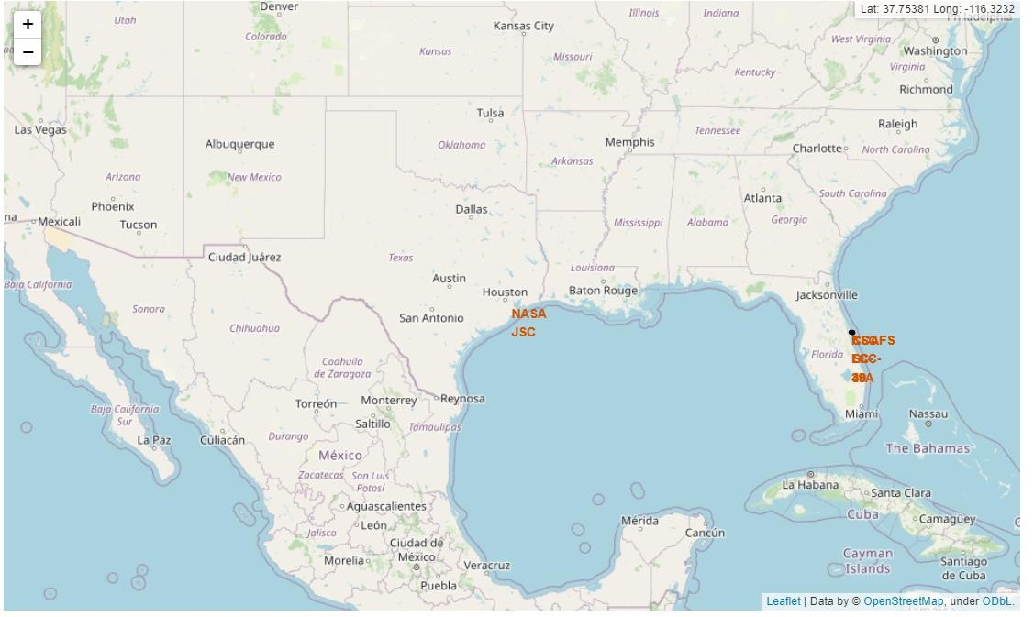37



# Totalsuccesslaunchesbyallsites



39

# Success ratebysite



40

# Payloadvslaunchoutcome



41



# ClassificationAccuracy

43

# ConfusionMatrix



44

# Conclusions

* TheSVM,KNN,andLogisticRegressionmodelsarethebestintermsof

predictionaccuracyforthisdataset.

* Lowweightedpayloadsperformbetterthantheheavierpayloads.
* ThesuccessratesforSpaceXlaunchesisdirectlyproportionaltimeinyearstheywilleventuallyperfectthelaunches.
* KSCLC39A hadthemostsuccessfullaunchesfromallthesites.
* OrbitGEO,HEO,SSO,ESL1hasthebestSuccessRate.

45

